- Install R : I have installed R
Screen Shot
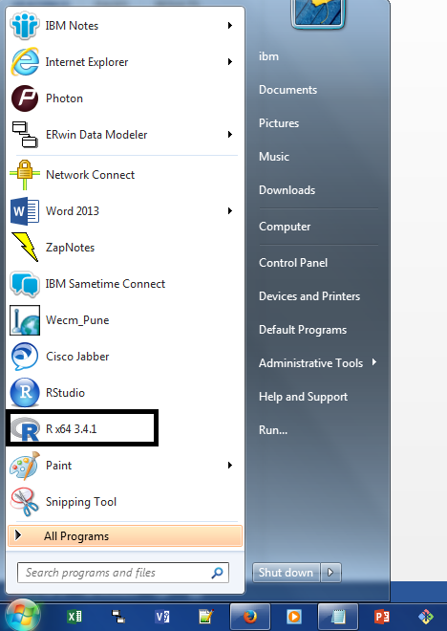

- Install Rstudio : I have installed R Studio
Screen shot
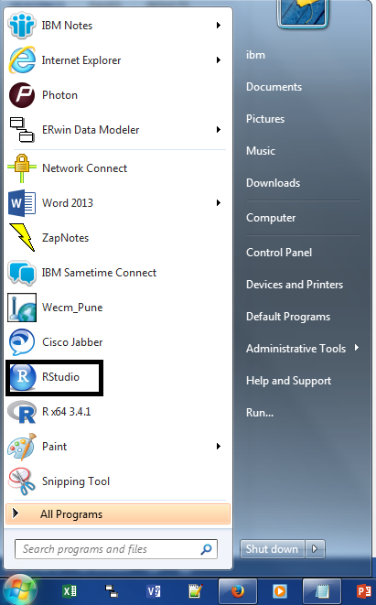

- Open Rstudio and take a screenshot
